Pre – Assessment/Post- Assessment

Select the best answer for each question listed below, write your answer on a separate sheet of paper. Each question is worth 1 point, unless otherwise noted, for a total of 20 points.

Use the diagram in figure 1 to answer questions 1 and 2.
.
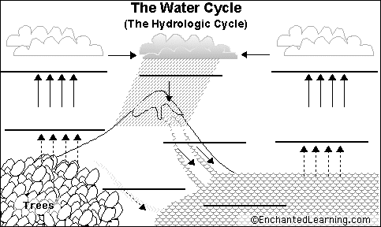
Figure 1: The water cycle
1.The name of the process that is taking place at the TREES is:
- transpiration b)evaporation c) precipitation d) condensation

2. The name of the process that is taking place at the top of the mountain is:
a) transpiration b) evaporation c) precipitation d) condensation

3. Water can enter the atmosphere by the processes of evaporation and:
- Condensation
- Transpiration (evapotranspiration)
- Seepage
- Filtration
- None of the choices are correct

4. Which of the following explanations describes how transpiration and seepage are related. (3 pts)
a) Water seeps into the plants roots. Water is used by plants for transpiration to make food. Water is returned to the atmosphere during condensation
b) Water enters the plants roots by transpiration. Water seeps into the plant so it can make food. Water is released back to the atmosphere by evaporation.
c) Water seeps through the soil and into the ground water. Roots of trees and plants take the water up through their roots. Plants release water through the process of transpiration.
d) Transpiration is a process used to make oxygen and water. The water that is created by plants seeps out of the organism goes directly into the ground and becomes ground water.
e) I do not have enough information to answer the question.

3. Short Answer: How might a large input of phosphorus affect a freshwater lake over time? (2pts)

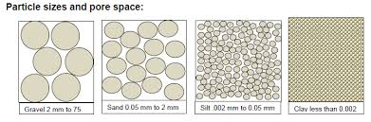
Figure 2: Particle sizes and pore space
For questions 4-6 refer to figure 2: particle sizes and pore space
4. Which material will have the highest permeability?
a) gravel b) sand c) silt d) clay
5. Which material will have the highest porosity?
a) gravel b) sand c) silt d) clay
6. Which of the following soil would be best to use if you wanted to stop a contaminant from entering an aquifer?
- Gravel b)clay c) soil d) sand e) none of these

7. The amount of empty space in a rock or other earth surface is referred to as:
- Permeability
- Porosity
- Percolation
- Infiltration
- None of the choices are correct

8. The rate at which water can pass through a substance is called: _______________
- Permeability b) Porosity c) Percolation d) Infiltration e)None of the choices are correct

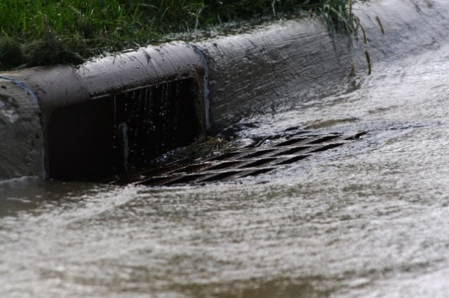
Figure 3: Rain water on asphalt

9. Refer to figure 3. List 2 pollutants that could be carried in water ruff-foff on asphalt. (2pts)
- b.

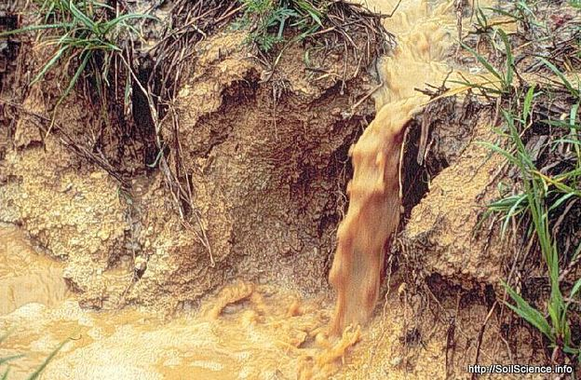
Figure 4: Rain water on field with vegetation.
10. Figure 4. List 2 pollutants that could be carried in water run-off that came from a field with vegetation. (2 pts)
a. b.

